**阶段性结果总结**

**由于文献中将数据分为了样本内和样本外两部分，其参数计算使用的是样本内数据，2月26日结果是用了所有样本数据统计的，所以差异较大，使用样本内数据重新验证。**

**一 数据核对**

1 时间范围

1. 样本内 2013.7.1～2013.9.6
2. 样本外 2013.9.9～2013.10.22
3. 数据范围 2013.7.1～2013.10.22

2 数据来源 预测者

3 相关性

|  |  |  |  |
| --- | --- | --- | --- |
|  | 样本内 | 所有样本 | 文献结果 |
| 30 | 0.9462 | 0.9611 | 0.960 |
| 15 | 0.9473 | 0.9620 | 0.961 |
| 5 | 0.9472 | 0.9622 | 0.962 |

结论：二者结果相似；

4 样本内数据统计值

|  |  |  |  |  |  |  |  |
| --- | --- | --- | --- | --- | --- | --- | --- |
|  | 平均值 | 中位值 | 最大值 | 最小值 | 标准偏差 | 偏度 | 峰度 |
| **Gj-30** | **12.4119** | **12.5700** | **13.4100** | **10.9400** | **0.5616** | **-1.0543** | **3.2161** |
| **Sx-30** | **6.4142** | **6.4600** | **6.9900** | **5.8600** | **0.2234** | **-0.8038** | **3.0000** |
| Gj-15 | 12.4086 | 12.5700 | 13.4100 | 10.9400 | 0.5604 | -1.0616 | 3.1945 |
| Sx-15 | 6.4128 | 6.4600 | 6.9900 | 5.8600 | 0.2227 | -0.8223 | 2.9492 |
| Gj-5 | 12.4058 | 12.5600 | 13.4300 | 10.9400 | 0.5601 | -1.0700 | 3.2007 |
| Sx-5 | 6.4116 | 6.4600 | 6.9900 | 5.8100 | 0.2230 | -0.8316 | 2.9404 |
| **RGj-30** | **12.4093** | **12.5700** | **13.4100** | **10.9500** | **0.5673** | **-1.0581** | **3.1958** |
| **RSx-30** | **6.4145** | **6.4650** | **6.9900** | **5.8600** | **0.2241** | **-0.8042** | **2.9991** |

*RGj、RSx为文献值

结论：二者相似。

**二 单位根检验**

检验最终结果一致，数据有差异

三 协整性检验

1 协整回归方程

|  |  |  |
| --- | --- | --- |
|  | 核对 | 文献 |
| 30 | GJ=-2.8598+2.3810SX | GJ=-2.9605+2.3961SX |
| 15 | GJ=-2.8855+2.3850SX | GJ=-2.9689+2.3975SX |
| 5 | GJ=-2.8524+2.3800SX | GJ=-3.004+2.4028SX |

结论：相似

2 残差单位根

|  |  |  |  |  |
| --- | --- | --- | --- | --- |
|  | 核对 | | 文献 | |
| 30 | -3.90 | 平稳 | -3.92 | 平稳 |
| 15 | -3.97 | 平稳 | -3.89 | 平稳 |
| 5 | -4.20 | 平稳 | -4.21 | 平稳 |

结论：相似

四 空间状态方程

1 验证结果

@signal GJ=sv1*SX+[var=exp(c(1))]

@state sv1=sv1(-1)

5分钟数据 验证结果

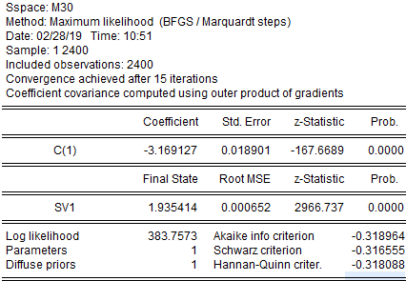

文献结果

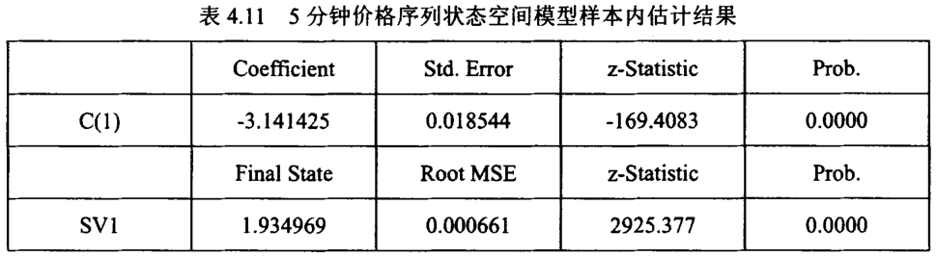

15分钟 验证结果

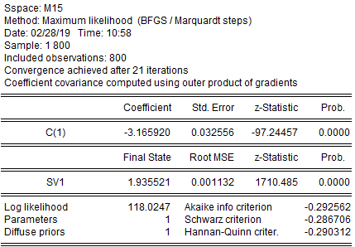

文献结果

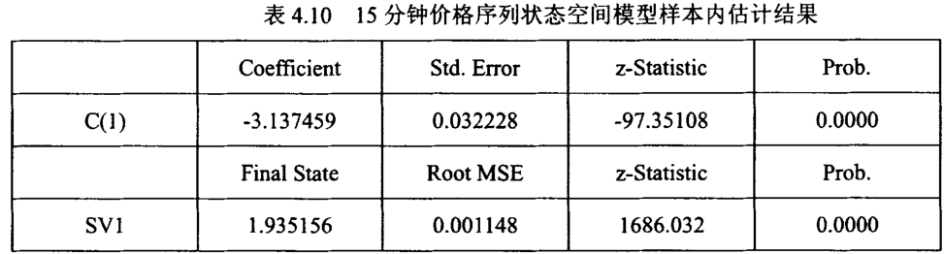

30分钟 验证结果

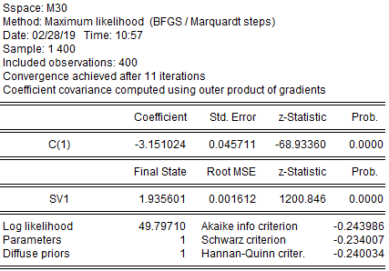

文献结果

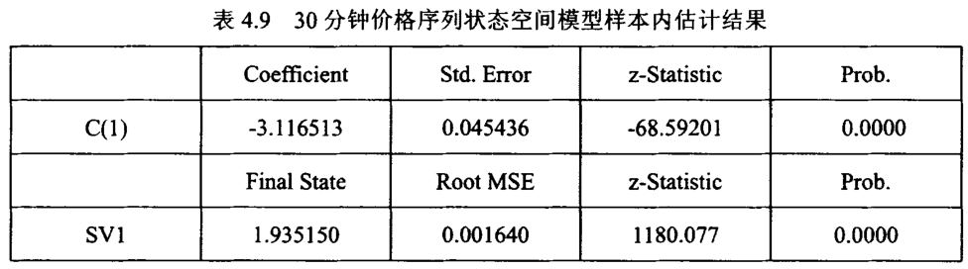

结论：相似

2 状态参数验证结果

验证结果 30分钟



文献结果 30分钟

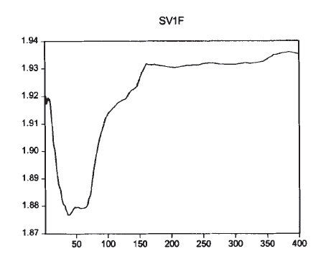

验证结果15分钟



文献结果15分钟

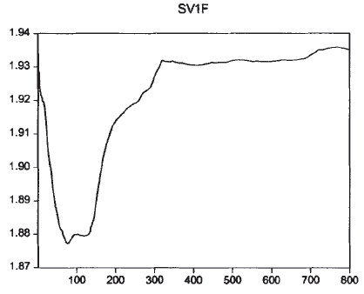

验证结果5分钟



验证结果5分钟

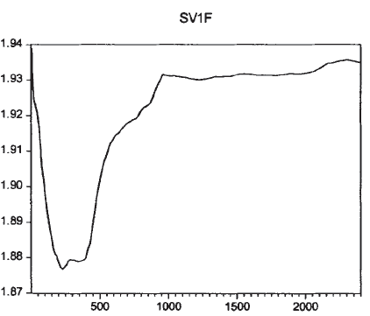

结论：相似，具体数值有微小差异。

3 残差序列分析

（1）残差图

验证结果



文献结果

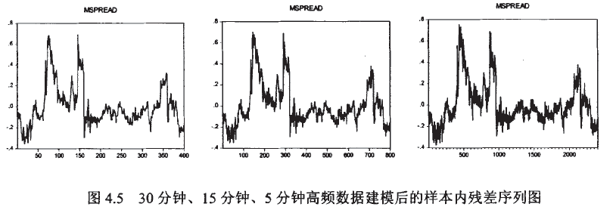

结论：相似。

（2）进场、套利图

|  |  |
| --- | --- |
| 验证 | 文献 |
|  |  |
|  |  |
|  |  |

结论：相似。

五 回测比对

1 参数对比

|  |  |  |
| --- | --- | --- |
|  | 验证 | 文献 |
| 30分钟 | 0.1928 | 0.1935 |
| 15分钟 | 0.1907 | 0.1910 |
| 5分钟 | 0.1906 | 0.1900 |

2 回测结果对比

由于后续内容过多，先写结论，再列具体结果。

结论：验证结果的进场、止损等信号和文献基本一致，可以判断由于数据差异的细微原因，验证结果和文献结果有差异，其中30分钟数据，验证数据结果多了一次止损信号，其余信号相同。15分钟信号，验证结果和文献结果相似，有几次止损信号位置不同；5分钟信号验证结果和文献结果都有很多止损信号，位置有细微差异。

累积收益统计

|  |  |  |
| --- | --- | --- |
|  | 验证 | 文献 |
| 30 | 2.60 | 6.79% |
| 15 | -2.50 | 2.34% |
| 5 | -9.97 | 0.74% |

从30分钟数据看，累积收益率差异原因有两个，1是二者的收盘数据有细微差异，即使信号位置相同，计算的收益率也不同；2是二者信号有细微差异。

核对结果可以通过交易数据来看。交易数据文件results30M.xlsx，results15M.xlsx，results5M.xlsx分别保存了30分钟、15分钟、5分钟数据的结果。文件左半部份为所有时间点的数据，格式为

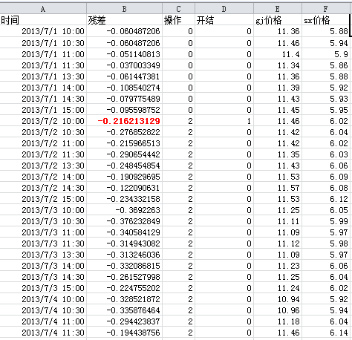

其中残差为计算交易信号的数值，操作表示发出的信号，开结列1表示开始，2表示结束。

文件右半部分为具体交易情况，计算公式同文献计算方法，其中第一个收益为股票收益，最后一列的收益为当期的净收益。

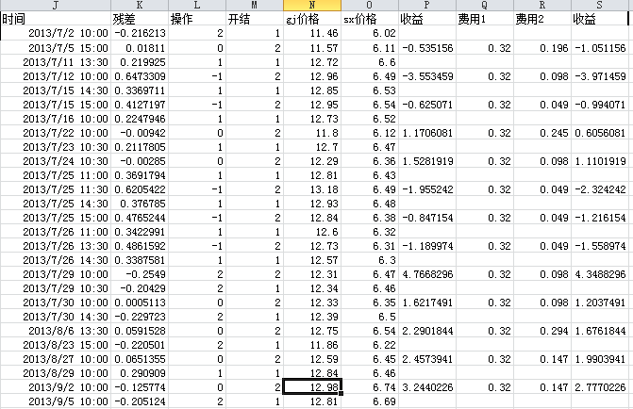

关于结果差异：

个人认为，差异的原因很可能是同花顺和预测者收盘价的细微差异导致的结果。如果能有同花顺的数据，就可以验证这个结论。如果您那里有其它数据源，方便的话可以发给我，我再验证下。

关于后续改进：

从后面的验证结果，以及附件中具体交易的情况可知，数据频率越高，该方法的闪烁信号越多，非常不利于收益。如何减少闪烁信号是策略改进的一个研究方向。

30分钟验证结果

验证结果

|  |  |  |  |  |  |  |  |  |  |  |
| --- | --- | --- | --- | --- | --- | --- | --- | --- | --- | --- |
|  | 时间 | 残差 | 操作 | 开结 | gj价格 | sx价格 | 交易收益 | 费用1 | 费用2 | 净收益 |
| 1 | 2013/7/2 10:00 | -0.21621 | 2 | 1 | 11.46 | 6.02 |  |  |  |  |
|  | 2013/7/5 15:00 | 0.01811 | 0 | 2 | 11.57 | 6.11 | -0.53516 | 0.32 | 0.196 | -1.05116 |
| 2 | 2013/7/11 13:30 | 0.219925 | 1 | 1 | 12.72 | 6.6 |  |  |  |  |
|  | 2013/7/12 10:00 | 0.647331 | -1 | 2 | 12.96 | 6.49 | -3.55346 | 0.32 | 0.098 | -3.97146 |
| 3 | **2013/7/15 14:30** | **0.336971** | **1** | **1** | **12.85** | **6.53** |  |  |  |  |
|  | **2013/7/15 15:00** | **0.41272** | **-1** | **2** | **12.95** | **6.54** | **-0.62507** | **0.32** | **0.049** | **-0.99407** |
| 4 | 2013/7/16 10:00 | 0.224795 | 1 | 1 | 12.73 | 6.52 |  |  |  |  |
|  | 2013/7/22 10:00 | -0.00942 | 0 | 2 | 11.8 | 6.12 | 1.170608 | 0.32 | 0.245 | 0.605608 |
| 5 | 2013/7/23 10:30 | 0.211781 | 1 | 1 | 12.7 | 6.47 |  |  |  |  |
|  | 2013/7/24 10:30 | -0.00285 | 0 | 2 | 12.29 | 6.36 | 1.528192 | 0.32 | 0.098 | 1.110192 |
| 6 | 2013/7/25 11:00 | 0.369179 | 1 | 1 | 12.81 | 6.43 |  |  |  |  |
|  | 2013/7/25 11:30 | 0.620542 | -1 | 2 | 13.18 | 6.49 | -1.95524 | 0.32 | 0.049 | -2.32424 |
| 7 | 2013/7/25 14:30 | 0.376785 | 1 | 1 | 12.93 | 6.48 |  |  |  |  |
|  | 2013/7/25 15:00 | 0.476524 | -1 | 2 | 12.84 | 6.38 | -0.84715 | 0.32 | 0.049 | -1.21615 |
| 8 | 2013/7/26 11:00 | 0.342299 | 1 | 1 | 12.6 | 6.32 |  |  |  |  |
|  | 2013/7/26 13:30 | 0.486159 | -1 | 2 | 12.73 | 6.31 | -1.18997 | 0.32 | 0.049 | -1.55897 |
| 9 | 2013/7/26 14:30 | 0.338758 | 1 | 1 | 12.57 | 6.3 |  |  |  |  |
|  | 2013/7/29 10:00 | -0.2549 | 2 | 2 | 12.31 | 6.47 | 4.76683 | 0.32 | 0.098 | 4.34883 |
| 10 | 2013/7/29 10:30 | -0.20429 | 2 | 1 | 12.34 | 6.46 |  |  |  |  |
|  | 2013/7/30 10:00 | 0.000511 | 0 | 2 | 12.33 | 6.35 | 1.621749 | 0.32 | 0.098 | 1.203749 |
| 11 | 2013/7/30 14:30 | -0.22972 | 2 | 1 | 12.39 | 6.5 |  |  |  |  |
|  | 2013/8/6 13:30 | 0.059153 | 0 | 2 | 12.75 | 6.54 | 2.290184 | 0.32 | 0.294 | 1.676184 |
| 12 | 2013/8/23 15:00 | -0.2205 | 2 | 1 | 11.86 | 6.22 |  |  |  |  |
|  | 2013/8/27 10:00 | 0.065136 | 0 | 2 | 12.59 | 6.45 | 2.457394 | 0.32 | 0.147 | 1.990394 |
| 13 | 2013/8/29 10:00 | 0.290909 | 1 | 1 | 12.84 | 6.46 |  |  |  |  |
|  | 2013/9/2 10:00 | -0.12577 | 0 | 2 | 12.98 | 6.74 | 3.244023 | 0.32 | 0.147 | 2.777023 |

文献结果

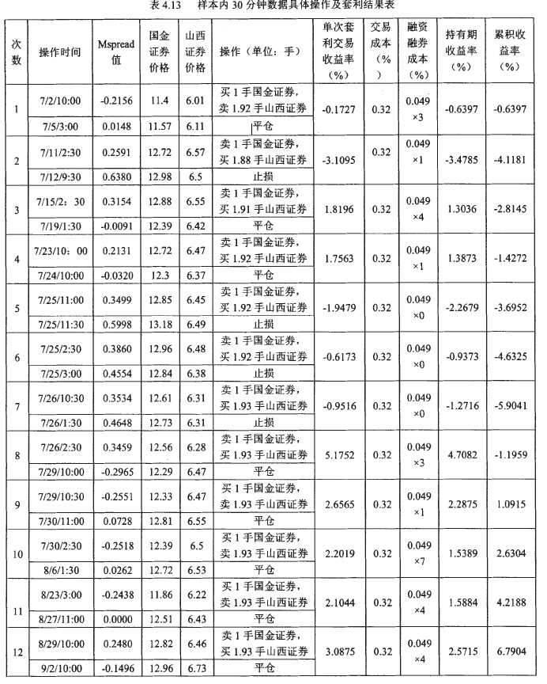

15分钟结果

|  |  |  |  |  |  |  |  |  |  |  |
| --- | --- | --- | --- | --- | --- | --- | --- | --- | --- | --- |
|  | 时间 | 残差 | 操作 | 开结 | gj价格 | sx价格 | 收益 | 费用1 | 费用2 | 收益 |
| 1 | 2013/7/2 10:00 | -0.214 | 2 | 1 | 11.46 | 6.02 |  |  |  |  |
| 2013/7/5 15:00 | 0.014 | 0 | 2 | 11.57 | 6.11 | -0.53516 | 0.32 | 0.196 | -1.05116 |
| 2 | 2013/7/11 11:15 | 0.240 | 1 | 1 | 12.26 | 6.35 |  |  |  |  |
| 2013/7/11 11:30 | 0.453 | -1 | 2 | 12.72 | 6.48 | -1.7048 | 0.32 | 0.049 | -2.0738 |
| 3 | 2013/7/11 13:30 | 0.220 | 1 | 1 | 12.72 | 6.6 |  |  |  |  |
| 2013/7/12 9:45 | 0.628 | -1 | 2 | 12.92 | 6.48 | -3.39051 | 0.32 | 0.098 | -3.80851 |
| 4 | 2013/7/15 14:15 | 0.364 | 1 | 1 | 12.97 | 6.58 |  |  |  |  |
| 2013/7/15 14:45 | 0.415 | -1 | 2 | 12.95 | 6.54 | -0.4537 | 0.32 | 0.049 | -0.8227 |
| 5 | 2013/7/16 9:45 | 0.271 | 1 | 1 | 12.87 | 6.57 |  |  |  |  |
| 2013/7/22 10:00 | -0.009 | 0 | 2 | 11.8 | 6.12 | 1.464593 | 0.32 | 0.245 | 0.899593 |
| 6 | 2013/7/23 10:15 | 0.191 | 1 | 1 | 12.64 | 6.45 |  |  |  |  |
| 2013/7/24 10:30 | -0.003 | 0 | 2 | 12.29 | 6.36 | 1.373639 | 0.32 | 0.098 | 0.955639 |
| 7 | 2013/7/25 10:15 | 0.349 | 1 | 1 | 12.88 | 6.48 |  |  |  |  |
| 2013/7/25 10:30 | 0.692 | -1 | 2 | 13.34 | 6.54 | -2.6455 | 0.32 | 0.049 | -3.0145 |
| 8 | 2013/7/25 11:00 | 0.369 | 1 | 1 | 12.81 | 6.43 |  |  |  |  |
| 2013/7/25 11:30 | 0.620 | -1 | 2 | 13.18 | 6.49 | -1.95524 | 0.32 | 0.049 | -2.32424 |
| 9 | 2013/7/25 14:30 | 0.376 | 1 | 1 | 12.93 | 6.48 |  |  |  |  |
| 2013/7/25 14:45 | 0.441 | -1 | 2 | 12.9 | 6.43 | -0.53959 | 0.32 | 0.049 | -0.90859 |
| 10 | 2013/7/26 10:45 | 0.343 | 1 | 1 | 12.6 | 6.32 |  |  |  |  |
| 2013/7/26 13:15 | 0.385 | -1 | 2 | 12.57 | 6.28 | -0.39482 | 0.32 | 0.049 | -0.76382 |
| 11 | 2013/7/26 14:15 | 0.362 | 1 | 1 | 12.65 | 6.33 |  |  |  |  |
| 2013/7/29 9:45 | -0.063 | 0 | 2 | 12.23 | 6.33 | 3.320158 | 0.32 | 0.098 | 2.902158 |
| 12 | 2013/7/29 10:00 | -0.253 | 2 | 1 | 12.31 | 6.47 |  |  |  |  |
| 2013/7/30 10:00 | 0.002 | 0 | 2 | 12.33 | 6.35 | 2.017184 | 0.32 | 0.098 | 1.599184 |
| 13 | 2013/7/30 14:30 | -0.228 | 2 | 1 | 12.39 | 6.5 |  |  |  |  |
| 2013/8/5 9:45 | 0.009 | 0 | 2 | 12.66 | 6.52 | 1.871484 | 0.32 | 0.245 | 1.306484 |
| 14 | 2013/8/16 9:45 | -0.193 | 2 | 1 | 12.6 | 6.59 |  |  |  |  |
| 2013/8/16 13:15 | 0.030 | 0 | 2 | 13.17 | 6.77 | 1.792398 | 0.32 | 0.049 | 1.423398 |
| 15 | 2013/8/23 14:45 | -0.200 | 2 | 1 | 11.88 | 6.22 |  |  |  |  |
| 2013/8/26 13:15 | 0.003 | 0 | 2 | 12.45 | 6.41 | 1.743317 | 0.32 | 0.098 | 1.325317 |
| 16 | 2013/8/29 10:00 | 0.291 | 1 | 1 | 12.84 | 6.46 |  |  |  |  |
| 2013/8/30 10:15 | 0.457 | -1 | 2 | 13.09 | 6.5 | -1.32785 | 0.32 | 0.098 | -1.74585 |
| 17 | 2013/8/30 10:30 | 0.252 | 1 | 1 | 13.04 | 6.58 |  |  |  |  |
| 2013/9/2 9:45 | -0.063 | 0 | 2 | 12.79 | 6.61 | 2.373105 | 0.32 | 0.098 | 1.955105 |
| 18 | 2013/9/2 10:15 | -0.213 | 2 | 1 | 12.93 | 6.76 |  |  |  |  |
| 2013/9/2 11:30 | 0.047 | 0 | 2 | 13.21 | 6.77 | 2.017578 | 0.32 | 0.049 | 1.648578 |

文献结果

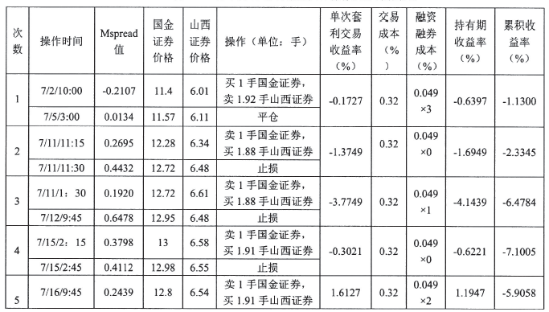

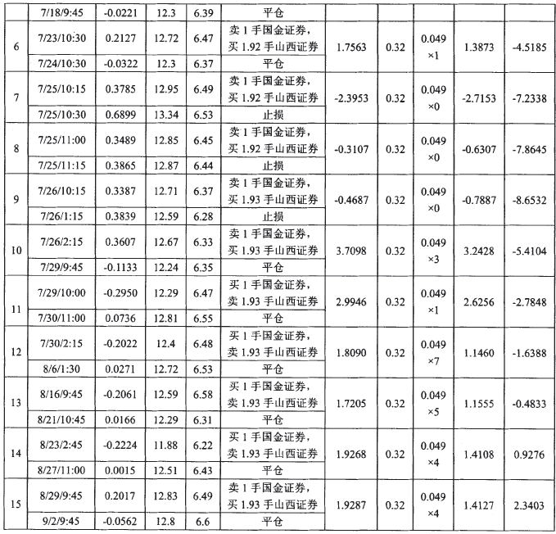

5分钟结果

|  |  |  |  |  |  |  |  |  |  |  |
| --- | --- | --- | --- | --- | --- | --- | --- | --- | --- | --- |
|  | 时间 | 残差 | 操作 | 开结 | gj价格 | sx价格 | 收益 | 费用1 | 费用2 | 收益 |
| 1 | 2013/7/2 9:35 | -0.19372 | 2 | 1 | 11.4 | 5.97 |  |  |  |  |
| 2013/7/3 10:10 | -0.38252 | -1 | 2 | 11.19 | 6.03 | -2.84713 | 0.32 | 0.098 | -3.26513 |
| 2 | 2013/7/3 10:15 | -0.35028 | 2 | 1 | 11.2 | 6.02 |  |  |  |  |
| 2013/7/3 10:25 | -0.41535 | -1 | 2 | 11.11 | 6.01 | -0.63746 | 0.32 | 0.049 | -1.00646 |
| 3 | 2013/7/3 10:30 | -0.37385 | 2 | 1 | 11.11 | 5.99 |  |  |  |  |
| 2013/7/3 10:50 | -0.38362 | -1 | 2 | 11.07 | 5.98 | -0.19309 | 0.32 | 0.049 | -0.56209 |
| 4 | 2013/7/3 11:00 | -0.33884 | 2 | 1 | 11.09 | 5.97 |  |  |  |  |
| 2013/7/4 14:50 | -0.41536 | -1 | 2 | 11.32 | 6.19 | -1.61115 | 0.32 | 0.098 | -2.02915 |
| 5 | 2013/7/4 14:55 | -0.32793 | 2 | 1 | 11.33 | 6.15 |  |  |  |  |
| 2013/7/5 15:00 | 0.012913 | 0 | 2 | 11.57 | 6.11 | 2.768677 | 0.32 | 0.098 | 2.350677 |
| 6 | 2013/7/11 11:10 | 0.29788 | 1 | 1 | 12.28 | 6.33 |  |  |  |  |
| 2013/7/11 11:25 | 0.543022 | -1 | 2 | 12.66 | 6.4 | -1.98862 | 0.32 | 0.049 | -2.35762 |
| 7 | 2013/7/11 13:10 | 0.315892 | 1 | 1 | 12.72 | 6.55 |  |  |  |  |
| 2013/7/11 14:50 | 0.394532 | -1 | 2 | 12.72 | 6.5 | -0.76336 | 0.32 | 0.049 | -1.13236 |
| 8 | 2013/7/11 14:55 | 0.37444 | 1 | 1 | 12.72 | 6.51 |  |  |  |  |
| 2013/7/12 9:35 | 0.559868 | -1 | 2 | 12.87 | 6.49 | -1.48646 | 0.32 | 0.098 | -1.90446 |
| 9 | 2013/7/15 10:10 | 0.340373 | 1 | 1 | 12.55 | 6.39 |  |  |  |  |
| 2013/7/15 10:15 | 0.398488 | -1 | 2 | 12.59 | 6.38 | -0.47522 | 0.32 | 0.049 | -0.84422 |
| 10 | 2013/7/15 13:40 | 0.359233 | 1 | 1 | 12.96 | 6.58 |  |  |  |  |
| 2013/7/15 13:45 | 0.448287 | -1 | 2 | 13.05 | 6.58 | -0.69444 | 0.32 | 0.049 | -1.06344 |
| 11 | 2013/7/15 14:10 | 0.360809 | 1 | 1 | 12.93 | 6.56 |  |  |  |  |
| 2013/7/15 14:25 | 0.453408 | -1 | 2 | 12.93 | 6.51 | -0.7622 | 0.32 | 0.049 | -1.1312 |
| 12 | 2013/7/15 14:30 | 0.334146 | 1 | 1 | 12.85 | 6.53 |  |  |  |  |
| 2013/7/15 14:35 | 0.422367 | -1 | 2 | 12.92 | 6.52 | -0.69789 | 0.32 | 0.049 | -1.06689 |
| 13 | 2013/7/16 9:35 | 0.364395 | 1 | 1 | 12.83 | 6.5 |  |  |  |  |
| 2013/7/22 9:40 | -0.09015 | 0 | 2 | 11.7 | 6.11 | 2.807482 | 0.32 | 0.245 | 2.242482 |
| 14 | 2013/7/23 10:20 | 0.21261 | 1 | 1 | 12.74 | 6.49 |  |  |  |  |
| 2013/7/24 10:30 | -0.00428 | 0 | 2 | 12.29 | 6.36 | 1.5291 | 0.32 | 0.098 | 1.1111 |
| 15 | 2013/7/24 14:25 | 0.20579 | 1 | 1 | 12.62 | 6.42 |  |  |  |  |
| 2013/7/25 10:20 | 0.427521 | -1 | 2 | 13 | 6.5 | -1.76499 | 0.32 | 0.098 | -2.18299 |
| 16 | 2013/7/25 11:00 | 0.366639 | 1 | 1 | 12.81 | 6.43 |  |  |  |  |
| 2013/7/25 11:05 | 0.487608 | -1 | 2 | 12.97 | 6.45 | -0.93798 | 0.32 | 0.049 | -1.30698 |
| 17 | 2013/7/25 11:15 | 0.346366 | 1 | 1 | 12.83 | 6.45 |  |  |  |  |
| 2013/7/25 11:20 | 0.448089 | -1 | 2 | 12.99 | 6.48 | -0.78196 | 0.32 | 0.049 | -1.15096 |
| 18 | 2013/7/25 14:30 | 0.374687 | 1 | 1 | 12.93 | 6.48 |  |  |  |  |
| 2013/7/25 14:35 | 0.491312 | -1 | 2 | 12.97 | 6.44 | -0.92664 | 0.32 | 0.049 | -1.29564 |
| 19 | 2013/7/26 10:25 | 0.367128 | 1 | 1 | 12.72 | 6.37 |  |  |  |  |
| 2013/7/26 10:30 | 0.403848 | -1 | 2 | 12.68 | 6.33 | -0.31348 | 0.32 | 0.049 | -0.68248 |
| 20 | 2013/7/26 10:35 | 0.284735 | 1 | 1 | 12.6 | 6.35 |  |  |  |  |
| 2013/7/26 11:20 | 0.385504 | -1 | 2 | 12.55 | 6.27 | -0.86302 | 0.32 | 0.049 | -1.23202 |
| 21 | 2013/7/26 11:25 | 0.312948 | 1 | 1 | 12.42 | 6.24 |  |  |  |  |
| 2013/7/26 13:10 | 0.452345 | -1 | 2 | 12.58 | 6.25 | -1.12799 | 0.32 | 0.049 | -1.49699 |
| 22 | 2013/7/26 14:15 | 0.361064 | 1 | 1 | 12.65 | 6.33 |  |  |  |  |
| 2013/7/26 14:20 | 0.390612 | -1 | 2 | 12.68 | 6.33 | -0.23715 | 0.32 | 0.049 | -0.60615 |
| 23 | 2013/7/26 14:25 | 0.358772 | 1 | 1 | 12.61 | 6.31 |  |  |  |  |
| 2013/7/29 9:35 | -0.08926 | 0 | 2 | 12.32 | 6.39 | 3.567591 | 0.32 | 0.098 | 3.149591 |
| 24 | 2013/7/29 9:55 | -0.27578 | 2 | 1 | 12.23 | 6.44 |  |  |  |  |
| 2013/7/30 10:00 | 0.001492 | 0 | 2 | 12.33 | 6.35 | 2.215177 | 0.32 | 0.098 | 1.797177 |
| 25 | 2013/7/30 14:30 | -0.22814 | 2 | 1 | 12.39 | 6.5 |  |  |  |  |
| 2013/8/5 9:45 | 0.010172 | 0 | 2 | 12.66 | 6.52 | 1.871484 | 0.32 | 0.245 | 1.306484 |
| 26 | 2013/8/16 9:40 | -0.19391 | 2 | 1 | 12.54 | 6.56 |  |  |  |  |
| 2013/8/16 13:05 | 0.02081 | 0 | 2 | 13.43 | 6.91 | 1.761923 | 0.32 | 0.049 | 1.392923 |
| 27 | 2013/8/23 13:50 | -0.20335 | 2 | 1 | 11.76 | 6.16 |  |  |  |  |
| 2013/8/26 13:15 | 0.004301 | 0 | 2 | 12.45 | 6.41 | 1.808905 | 0.32 | 0.098 | 1.390905 |
| 28 | 2013/8/29 9:50 | 0.324115 | 1 | 1 | 12.91 | 6.48 |  |  |  |  |
| 2013/8/30 10:15 | 0.458161 | -1 | 2 | 13.09 | 6.5 | -1.08563 | 0.32 | 0.098 | -1.50363 |
| 29 | 2013/8/30 10:20 | 0.30988 | 1 | 1 | 13 | 6.53 |  |  |  |  |
| 2013/8/30 13:50 | 0.39681 | -1 | 2 | 13.11 | 6.54 | -0.69301 | 0.32 | 0.049 | -1.06201 |
| 30 | 2013/8/30 13:55 | 0.337239 | 1 | 1 | 13.07 | 6.55 |  |  |  |  |
| 2013/9/2 9:35 | -0.05825 | 0 | 2 | 12.89 | 6.66 | 3.056589 | 0.32 | 0.098 | 2.638589 |
| 31 | 2013/9/2 10:15 | -0.21168 | 2 | 1 | 12.93 | 6.76 |  |  |  |  |
| 2013/9/2 11:20 | 0.035847 | 0 | 2 | 13.1 | 6.72 | 1.906488 | 0.32 | 0.049 | 1.537488 |

文献结果

